Department of Computer Engineering

Practical - 13

Practical Title: PHP JSON API and AJAX/Fetch-Based CRUD without Page Reload

Problem Definition: Create PHP JSON API endpoints for students and consume them using the Fetch API. Perform list, add, update, and delete operations asynchronously without full page reload.

Theory :
- Do PHP endpoints return valid JSON responses?
Yes. All endpoints in api/students.php set Content-Type: application/json and return standardized JSON objects (status, message, data, count) alongside HTTP status codes (200, 201, 400, 404, 422).

Are GET and POST requests handled properly?
Yes. GET requests list and search records. POST bodies are parsed via file_get_contents('php://input') and decoded with json_decode() to handle asynchronous create, update, and delete actions.

Are loading, success, and error states shown on the frontend?
Yes. A CSS spinner indicates active network requests; toast notifications confirm success; error alerts surface validation or network failures.

How is AJAX search optimized with debounce?
A 300ms debounce timer resets with every keystroke and fires the Fetch API GET request only after typing pauses for 300 milliseconds, preventing excessive network calls.
Implementation / Output / Result
// Asynchronous Fetch API POST without Page Reload const response = await fetch('api/students.php', {
method: 'POST',
headers: { 'Content-Type': 'application/json' },
body: JSON.stringify({ action: 'create', full_name, email, course, ... })
});
const res = await response.json();
if (res.status === 'success') showToast(res.message);

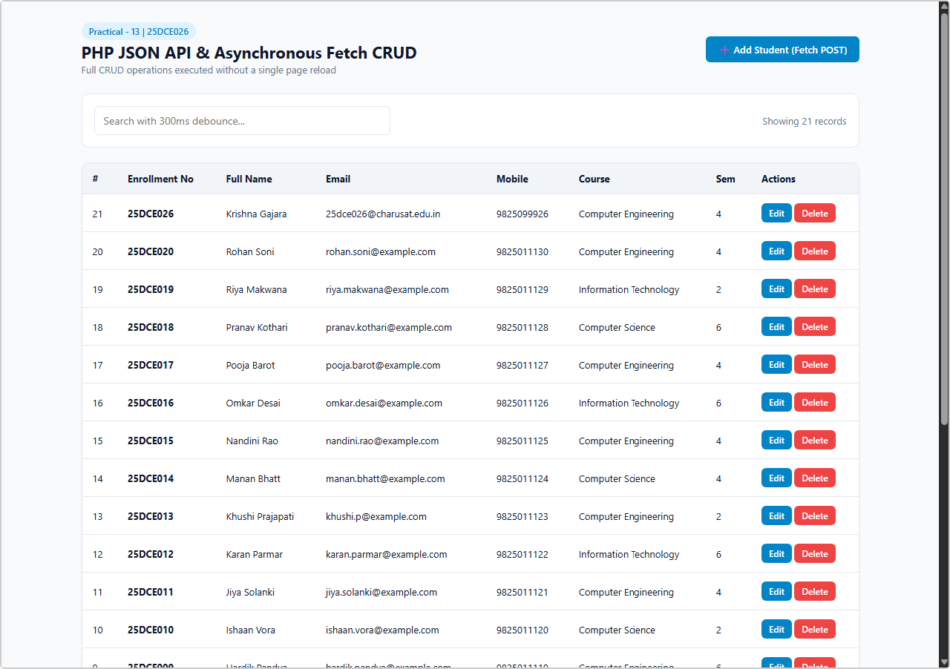
GitHub Repository Link:
Output 1: Fetch API Single Page Application (SPA) with Live Debounced Search
Live browser screenshot: Full SPA with student table, debounced live search input, Add Student modal button — zero page reloads.

https://github.com/bhavya13032007/studenthub/tree/main

Learning Outcomes:
- Built RESTful JSON backend APIs with PHP and MySQLi.
- Mastered JavaScript Fetch API using async/await and Promises for asynchronous operations.
- Developed a Single Page Application (SPA) performing complete CRUD without browser refreshes.
- Managed asynchronous UI feedback states including loading spinners and toast notifications.
- Optimized client-to-server traffic using a 300ms search input debounce algorithm.
- Utilized browser developer network inspection tools to verify API request/response lifecycles.

